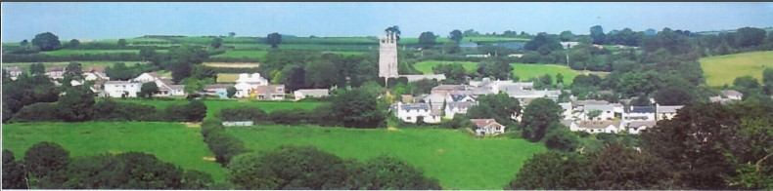
7th June 2026
Dear Councillor,
You are summoned to attend a meeting of North Hill Parish Council on Wednesday 10th June 2026 at 7.00pm at North Hill Village Hall.
Please find attached the agenda for our meeting. We ask that if any member of the public has issues, they would like to raise that they contact the clerk prior to the meeting so that we can best manage them.
Please remember that the time allotted for Matters of Community Concern is not a forum to discuss what has taken place during this meeting and that any matter raised here would likely be added to the NEXT meeting agenda for discussion.
Yours faithfully,

Lena Batten, Clerk to the Council
Members of the public are welcome to attend the meeting. However, we would like those attending to register prior to the meeting by emailing the Parish Clerk. Email: clerk@northhillparish.org.uk
AGENDA
- TO RECEIVE APOLOGIES:
- CODE OF CONDUCT : a) TO RECEIVE DECLARATIONS b) TO GRANT DISPENSATIONS:
3. TO REVIEW CORRESPONDENCE AND TO AGREED RESPONSES REQUIRED:
3.1 To consider / resolve email received from BDO auditors stating that North Hill Parish Council can
claim exemption due to figures being submitted on an income / expenditure basis which puts North
Hill Parish Council under the threshold for external audit.
4. CLOSE OF BUSINESS:

